No smart combiners? No problem.
Monitor the DC side of your system for subcombiner and recombiner data.
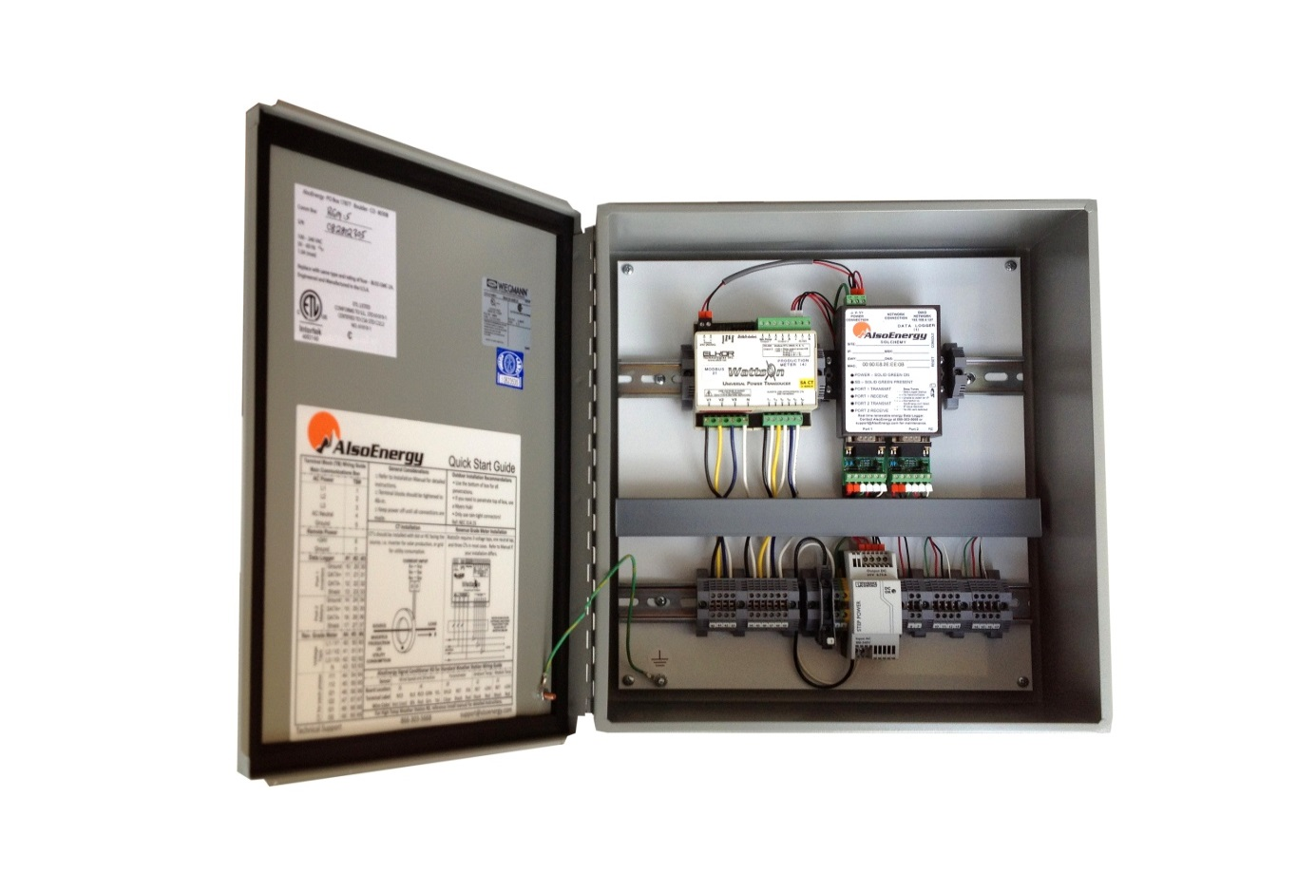
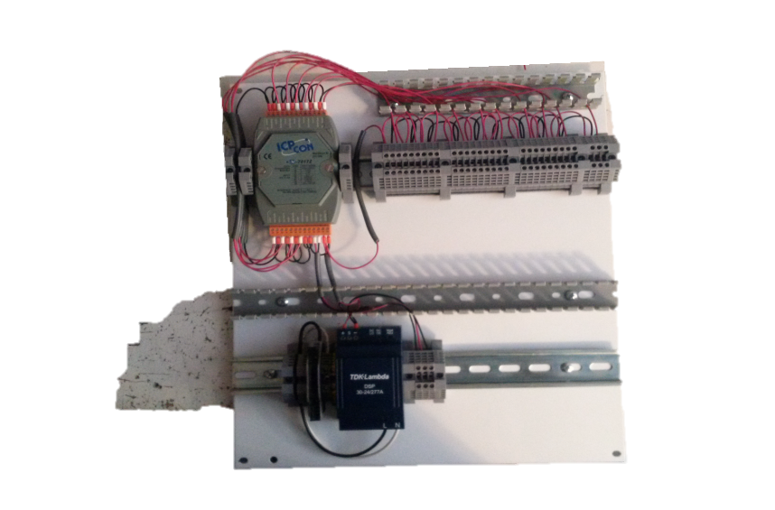

Features
- NEMA 4 rated enclosure
- Plug and play installation
- 5 year warranty

- 10 channel iputs for up to 10 zones
- Split-Core DC CTs for easy installation and replacements
- No need to route DC feeders through the enclosure, CT leads extend up to 30’
- CTs avaiale for 250 A and greater

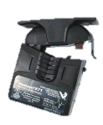
Part ID | Veris EA20BB020
 | 0-200A
 | 4-20mA Output
Window | 1 1/8”
Part ID | CTH-401LST
 | 0-400A
 | 4-20mA ouput
Window | 1 1/8”
Higher Amperage models avaiable

